**PL_SQL**

EXERCISE1: CONTROL STRUCTURES

SET SERVEROUTPUT ON;

CREATE TABLE customers (

customer_id NUMBER PRIMARY KEY,

customer_name VARCHAR2(100),

age NUMBER,

balance NUMBER,

loan_interest_rate NUMBER,

isvip VARCHAR2(5)

);

CREATE TABLE loans (

loan_id NUMBER PRIMARY KEY,

customer_id NUMBER REFERENCES customers(customer_id),

due_date DATE

);

Insert sample data

INSERT INTO customers VALUES (1, 'John Doe', 65, 12000, 8.5, 'FALSE');

INSERT INTO customers VALUES (2, 'Jane Smith', 45, 9000, 9.0, 'FALSE');

INSERT INTO customers VALUES (3, 'Mark Lee', 70, 10500, 7.5, 'FALSE');

INSERT INTO loans VALUES (101, 1, SYSDATE + 10); -- due soon

INSERT INTO loans VALUES (102, 2, SYSDATE + 45); -- not due

INSERT INTO loans VALUES (103, 3, SYSDATE + 5); -- due soon

COMMIT;

Scenario 1 - Apply 1% discount to interest rate for age > 60

BEGIN

FOR customer_rec IN (

SELECT customer_id, age, loan_interest_rate FROM customers WHERE age > 60

) LOOP

UPDATE customers

SET loan_interest_rate = loan_interest_rate - 1

WHERE customer_id = customer_rec.customer_id;

END LOOP;

DBMS_OUTPUT.PUT_LINE('Scenario 1: Interest rate discount applied for customers above 60.');

END;

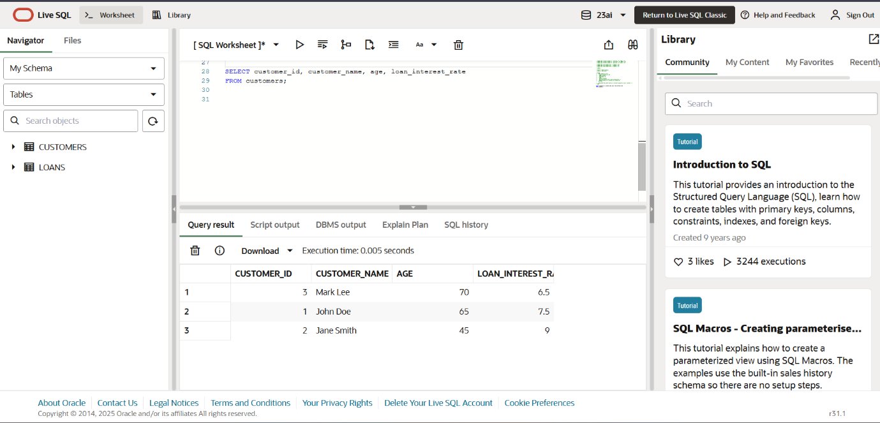

Scenario 2 - Set IsVIP = TRUE for balance > 10000

BEGIN

FOR customer_rec IN (

SELECT customer_id, balance FROM customers WHERE balance > 10000

) LOOP

UPDATE customers

SET isvip = 'TRUE'

WHERE customer_id = customer_rec.customer_id;

END LOOP;

DBMS_OUTPUT.PUT_LINE('Scenario 2: VIP status updated for eligible customers.');

END;

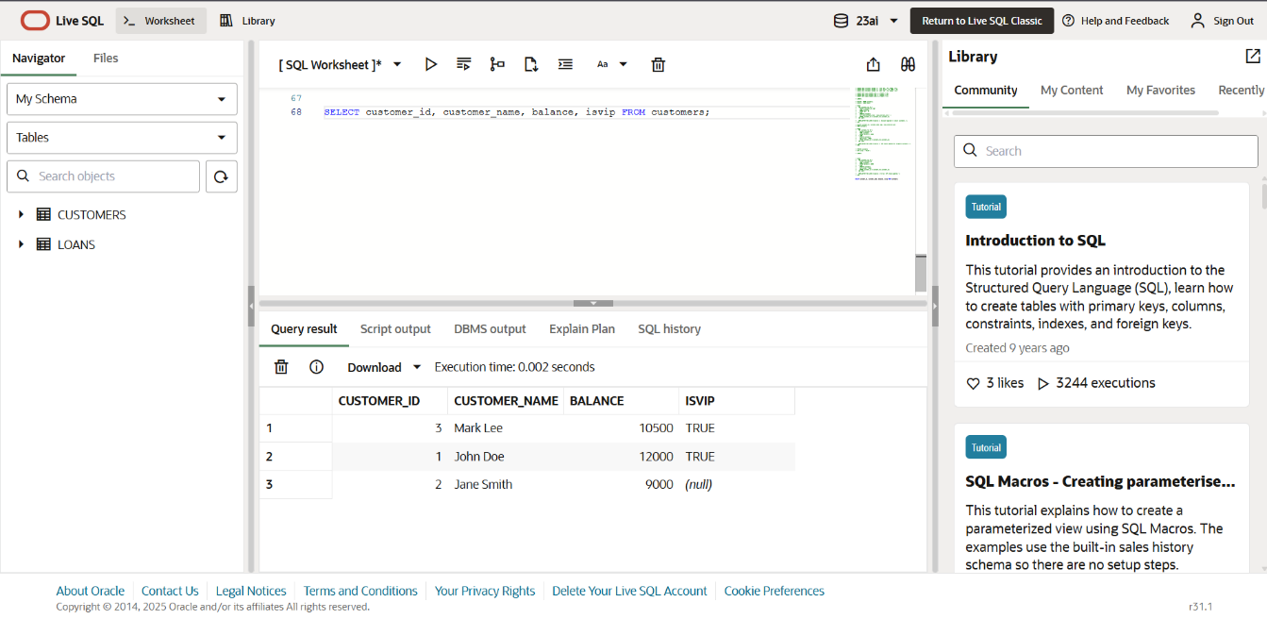

Scenario 3 - Remind customers of loans due in next 30 days

BEGIN

FOR loan_rec IN (

SELECT l.loan_id, c.customer_name, l.due_date

FROM loans l

JOIN customers c ON l.customer_id = c.customer_id

WHERE l.due_date BETWEEN SYSDATE AND SYSDATE + 30

) LOOP

DBMS_OUTPUT.PUT_LINE('Reminder: Loan ID ' || loan_rec.loan_id ||

' for customer ' || loan_rec.customer_name ||

' is due on ' || TO_CHAR(loan_rec.due_date, 'DD-MON-YYYY'));

END LOOP;

END;

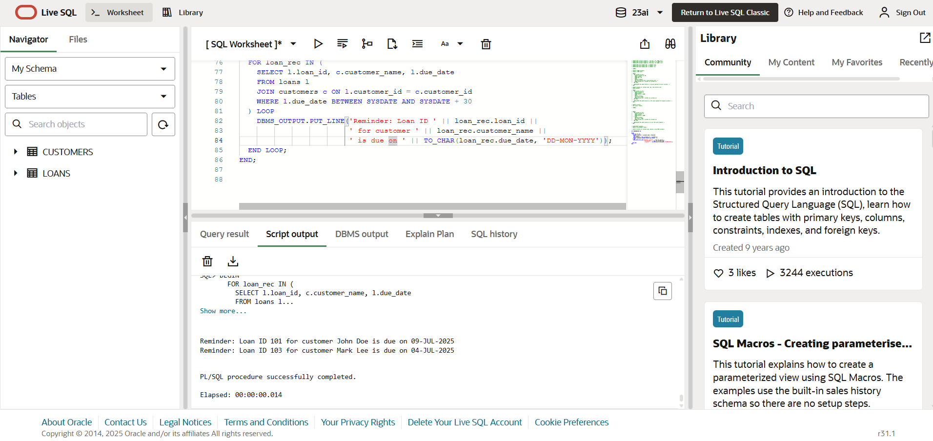

**PL_SQL**

EXERCISE 3 : STORED PROCEDURES

BEGIN

EXECUTE IMMEDIATE 'DROP TABLE savings_accounts';

EXECUTE IMMEDIATE 'DROP TABLE employees';

EXECUTE IMMEDIATE 'DROP TABLE bank_accounts';

EXCEPTION

WHEN OTHERS THEN NULL;

END;

CREATE TABLE savings_accounts (

account_id NUMBER PRIMARY KEY,

customer_id NUMBER,

balance NUMBER

);

CREATE TABLE employees (

emp_id NUMBER PRIMARY KEY,

name VARCHAR2(100),

department VARCHAR2(50),

salary NUMBER

);

CREATE TABLE bank_accounts (

account_id NUMBER PRIMARY KEY,

customer_id NUMBER,

balance NUMBER

);

INSERT INTO savings_accounts VALUES (201, 1, 5000);

INSERT INTO savings_accounts VALUES (202, 2, 10000);

INSERT INTO employees VALUES (1, 'Alice', 'Sales', 50000);

INSERT INTO employees VALUES (2, 'Bob', 'HR', 40000);

INSERT INTO employees VALUES (3, 'Charlie', 'Sales', 55000);

INSERT INTO bank_accounts VALUES (101, 1, 1000); -- from account

INSERT INTO bank_accounts VALUES (102, 2, 500); -- to account

COMMIT;

CREATE OR REPLACE PROCEDURE ProcessMonthlyInterest AS

BEGIN

FOR acc IN (SELECT account_id, balance FROM savings_accounts) LOOP

UPDATE savings_accounts

SET balance = balance + (balance * 0.01)

WHERE account_id = acc.account_id;

END LOOP;

DBMS_OUTPUT.PUT_LINE('Monthly interest processed.');

END;

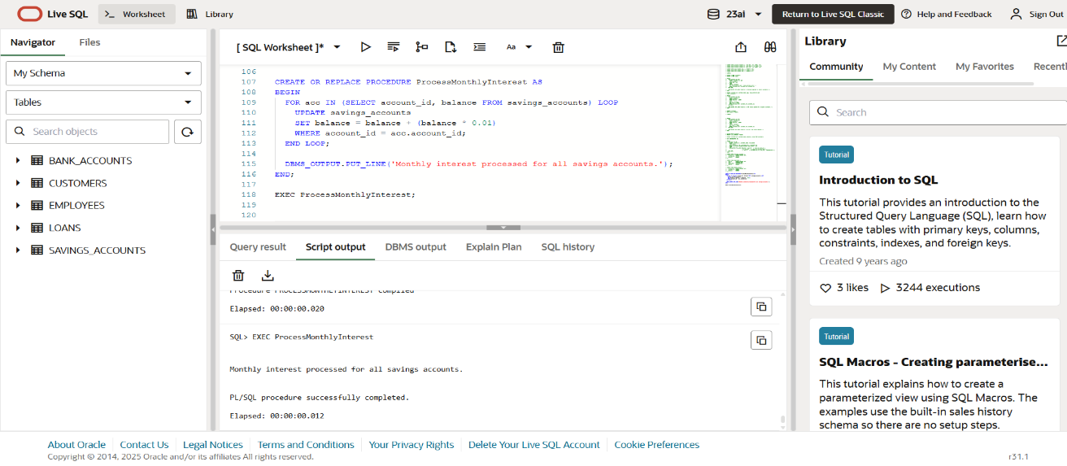

CREATE OR REPLACE PROCEDURE UpdateEmployeeBonus(

dept_name IN VARCHAR2,

bonus_pct IN NUMBER

) AS

BEGIN

UPDATE employees

SET salary = salary + (salary * bonus_pct / 100)

WHERE department = dept_name;

DBMS_OUTPUT.PUT_LINE('Bonus applied to department: ' || dept_name);

END;

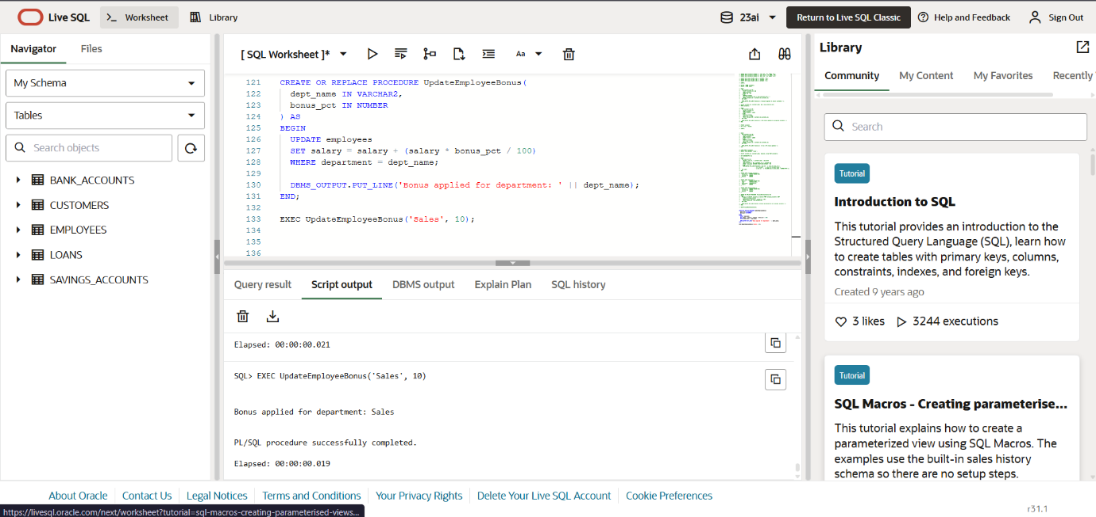

CREATE OR REPLACE PROCEDURE TransferFunds(

from_account_id IN NUMBER,

to_account_id IN NUMBER,

amount IN NUMBER

) AS

from_balance NUMBER;

BEGIN

SELECT balance INTO from_balance

FROM bank_accounts

WHERE account_id = from_account_id;

IF from_balance < amount THEN

RAISE_APPLICATION_ERROR(-20001, 'Insufficient balance');

END IF;

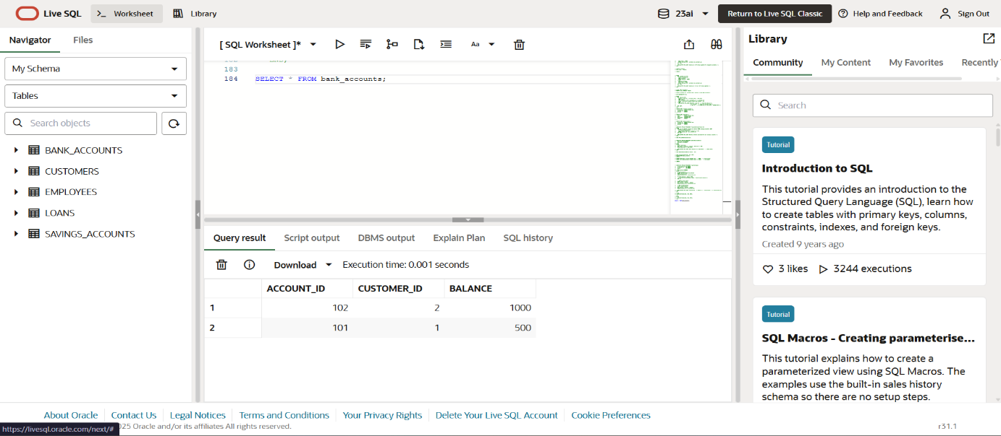

UPDATE bank_accounts

SET balance = balance - amount

WHERE account_id = from_account_id;

UPDATE bank_accounts

SET balance = balance + amount

WHERE account_id = to_account_id;

DBMS_OUTPUT.PUT_LINE('Transferred ' || amount || ' from Account ' || from_account_id || ' to Account ' || to_account_id);

END;

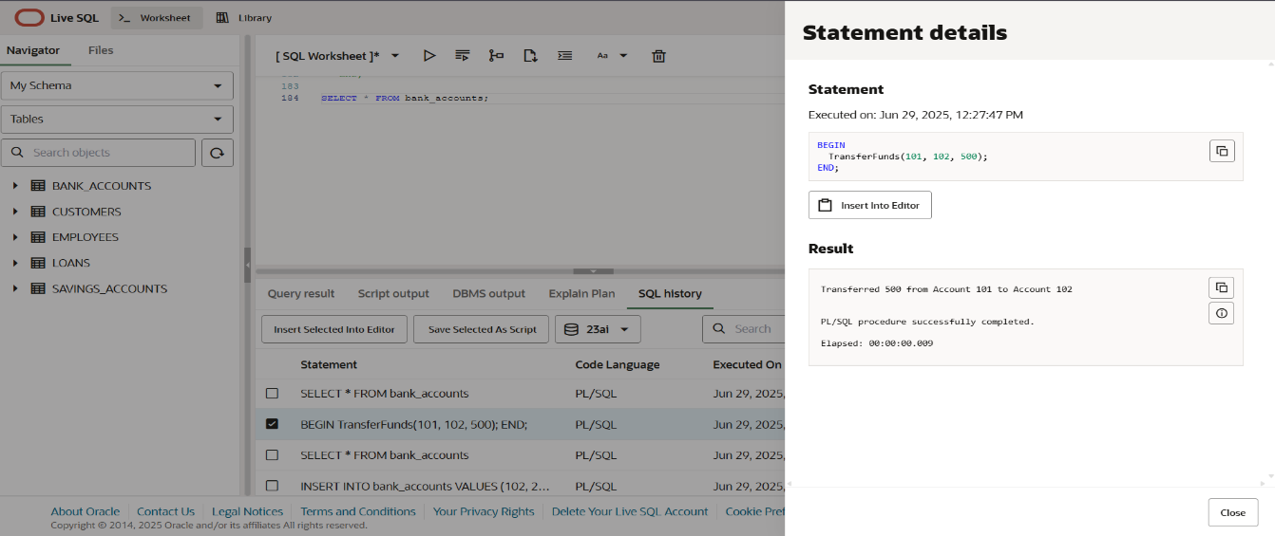

SET SERVEROUTPUT ON;

BEGIN

ProcessMonthlyInterest;

END;

BEGIN

UpdateEmployeeBonus('Sales', 10);

END;

BEGIN

TransferFunds(101, 102, 500);

END;

Final Output Checks :

SELECT * FROM savings_accounts;

SELECT * FROM employees;

SELECT * FROM bank_accounts;